Title: wide and deep learning for recommender system

Author: Heng-Tze Cheng

Source: google

Abstract:  
wide and deep learning can jointly trained wide linear models and deep neural networks.

Introduction:

Recommend system has two important things: memorization and generalization

The main contribution of the paper:  
1. The wide and deep learning framework for jointly training feed-forward neural networks with embeddings and linear model with feature transformation for generic recommender system with sparse inputs.

下面是它的结构图：  
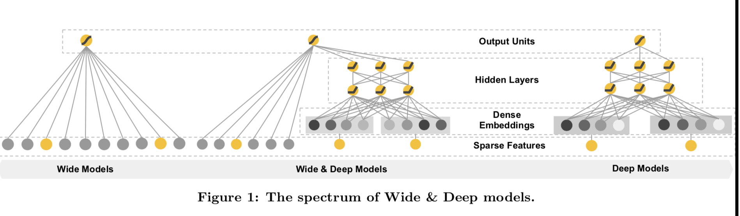

Recommender system overview

The wide and deep learning model is a ranking model

Wide and deep learning

3.1 the wide component

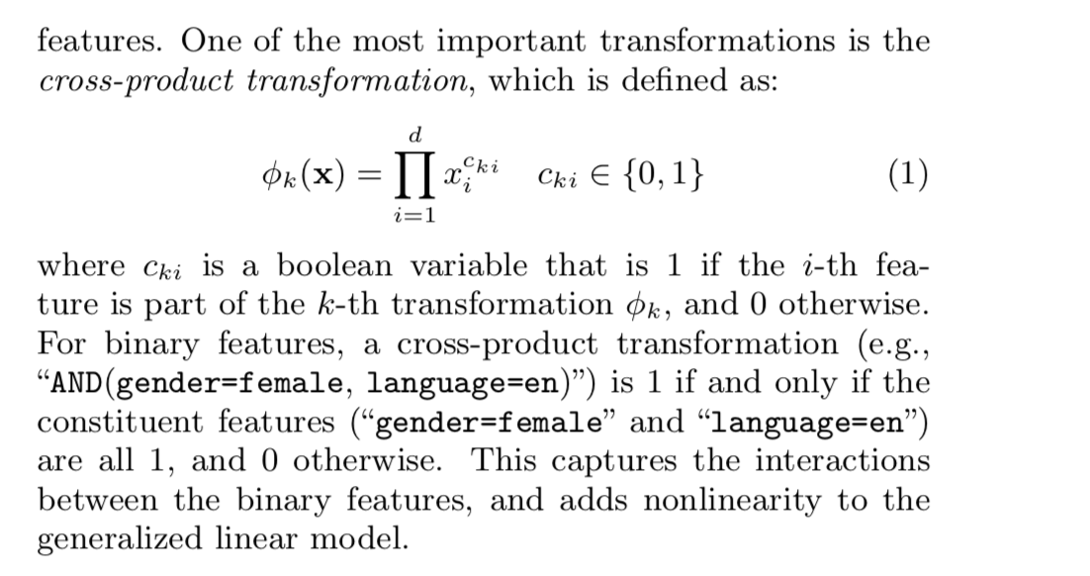

3.2 the deep component

深度网络部分是一个前向神经网络，它首先将原始的稀疏的高维的数据转变为低维的稠密的数据，通常指的是embedding vector.隐含层单元的激活函数是ReLUs

3.3 joint training of wide and deep model

Joint training和ensemble是有区别的。Ensemble，每个模型之间是相互独立的，而对于joint training而言，In contrast, joint training optimizes all parameters simultaneously by taking both the wide and deep part as well as the weights of their sum into account at training time.

Joint training of wide and deep model 是通过后向传播和mini-batch 随机优化实现的。wide part of the model采用的FTRL模型，deep part of the model采用的AdaGrad

System implementation

4.2 model training

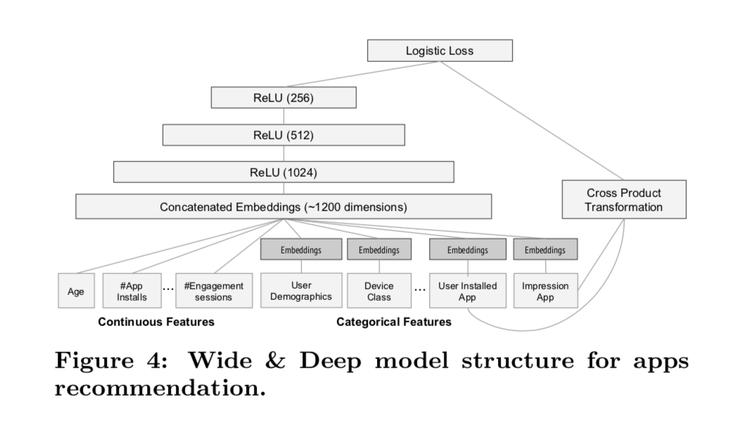

4.3 model serving

通过多线程并行化来并行的跑小的batches，而不是在一个batch里面计算所有的app的得分

Experiment result

没什么特别的，就是效果比较好而且延迟也比较小

Related work

Wide and deep learning model和FM的相似之处在于，FM的作用是通过点乘发现两个变量之间的linear interaction 而 wide and deep learning model可以通过神经网络用于发现nonlinear interactions

Conclusion

Memorization and generalization are both important foe recommender systems. Wide linegar models can effectively memorize sparse feature interactions using cross-product feature transformations, while deep neural networks can generalize to previously unseen feature interactions through low dimensional embeddings. We presented the wide and deep learning framework to combine the strength of both types of model. We productionized and evaluated the framework on the recommender system of google play, a massive scale commercial app store. Online experiment results showed that the wide and deep model led to significant improvement on app acquisitions over wide-only and deep-only models.